**DAILY ONLINE ACTIVITIES SUMMARY**

|  |  |  |  |  |  |  |  |  |
| --- | --- | --- | --- | --- | --- | --- | --- | --- |
| **Date:** | **14/06/2020** | | | | | **Name:** | **Shailashree** | |
| **Sem & Sec** | **IV sem & B section** | | | | | **USN:** | **4AL18CS077** | |
| **Online Test Summary** | | | | | | | | |
| **Subject** | | **-** | | | | | | |
| **Max. Marks** | | **30** | | **Score** | | | **-** | |
| **Certification Course Summary** | | | | | | | | |
| **Course** | **Introduction to Ethical Hacking** | | | | | | | |
| **Certificate Provider** | | | **Great learning academy** | | **Duration** | | | **4.0 hours** |
| **Coding Challenges** | | | | | | | | |
| **Problem Statement1:** Write a C program to remove specific characters in the String. | | | | | | | | |
| **Status: Executed** | | | | | | | | |
| **Uploaded the report in GitHub** | | | | | **YES** | | | |
| **If yes Repository name** | | | | | **Online-coding** | | | |
| **Uploaded the report in slack** | | | | | **YES** | | | |

Online Test Summary: No internals conducted today.

Online Certification Course Summary: In today’s session I have learnt what is Ethical Hacking and also the demonstration of the same and also came to know about black hat, grey hat and white hat Hackers and also the goals of the Ethical Hacking.

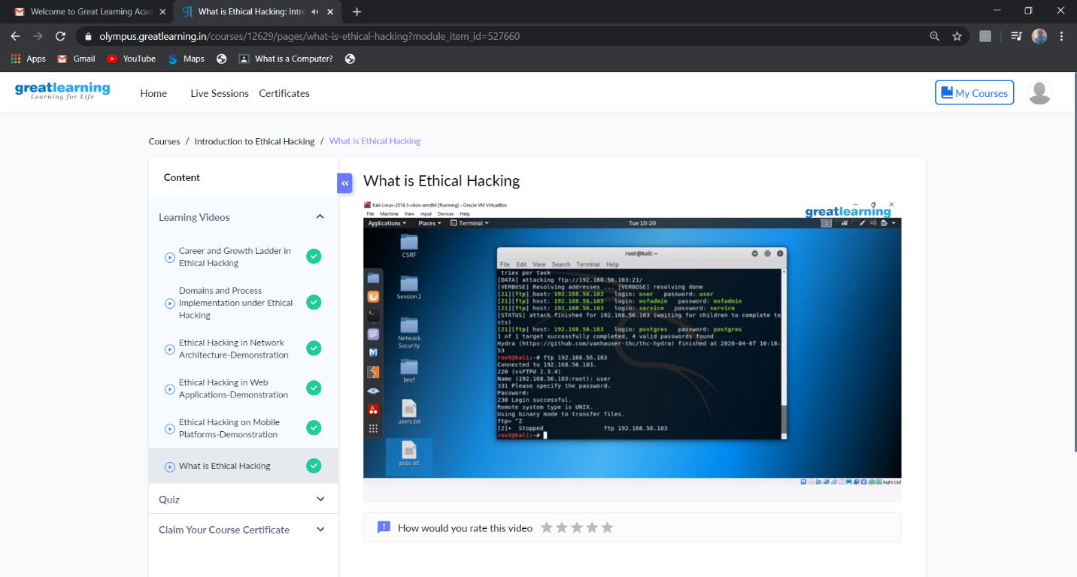

This is the Snap Shot of today’s session.

I participated in E-QUIZ on “OPERATING SYSTEMS” Organized by the Department of Computer Science and Engineering, Moodlakatte Institute of Technology, Kundapur on 6-06-2020.

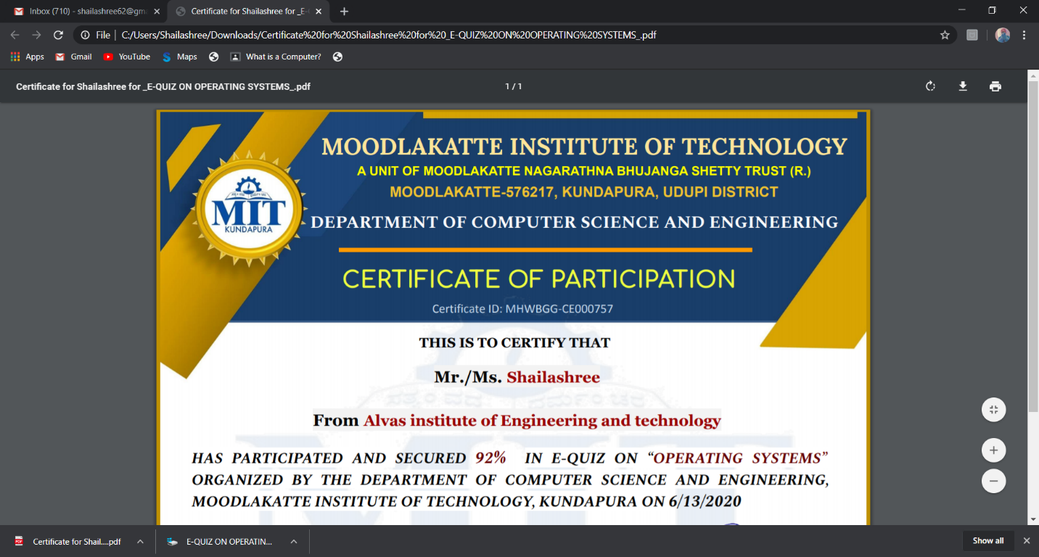

This is the screen shot of the certificate that I got from MIT Institute.

I participated and completed the quiz on “Python” organized by Department of Computer Engineering on 11-06-2000.

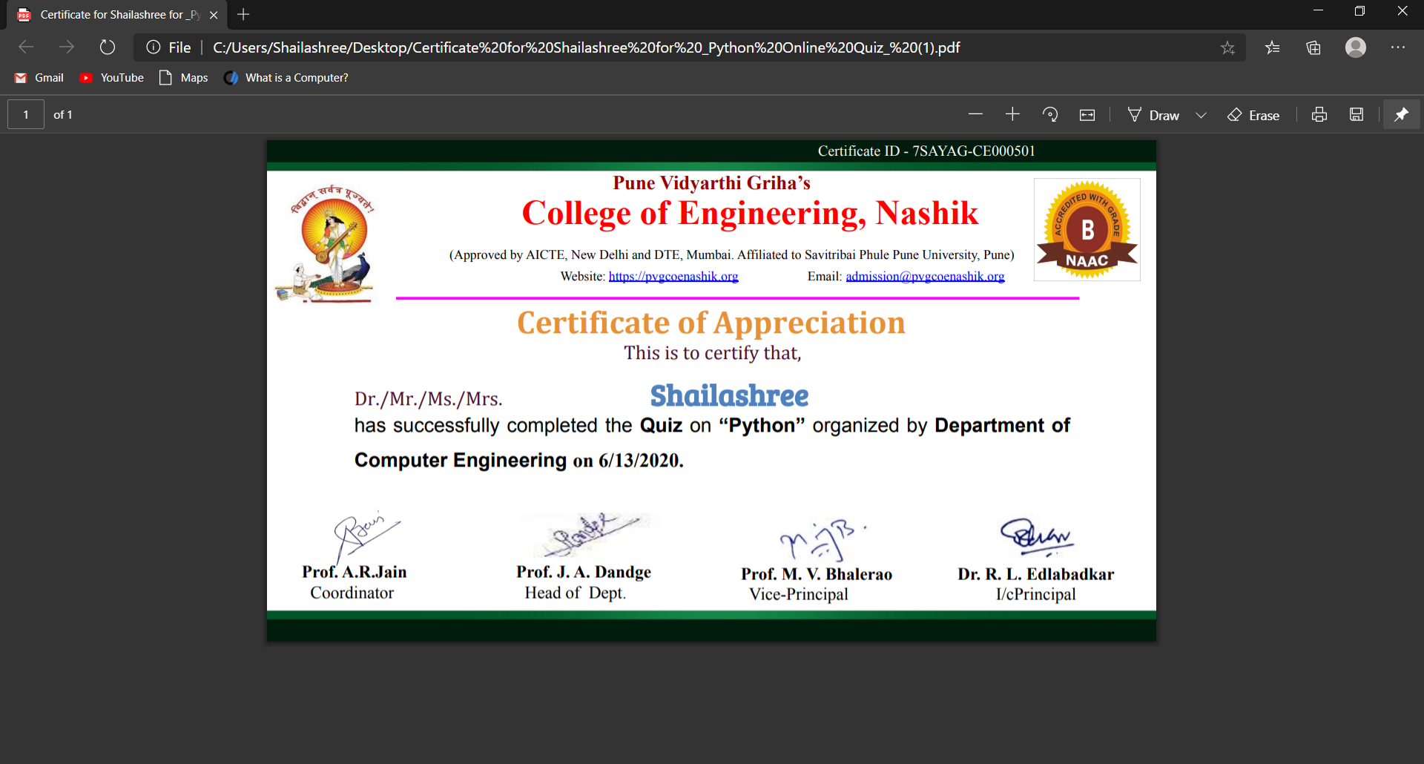

This the screen shot of the certificate that I got for participation.

Online Coding Summary: **Today I had received one program from prof. Shilpa CSE Dept. The program is mentioned above in the coding challenges(pg.01). I have also uploaded it to my GitHub repository.**

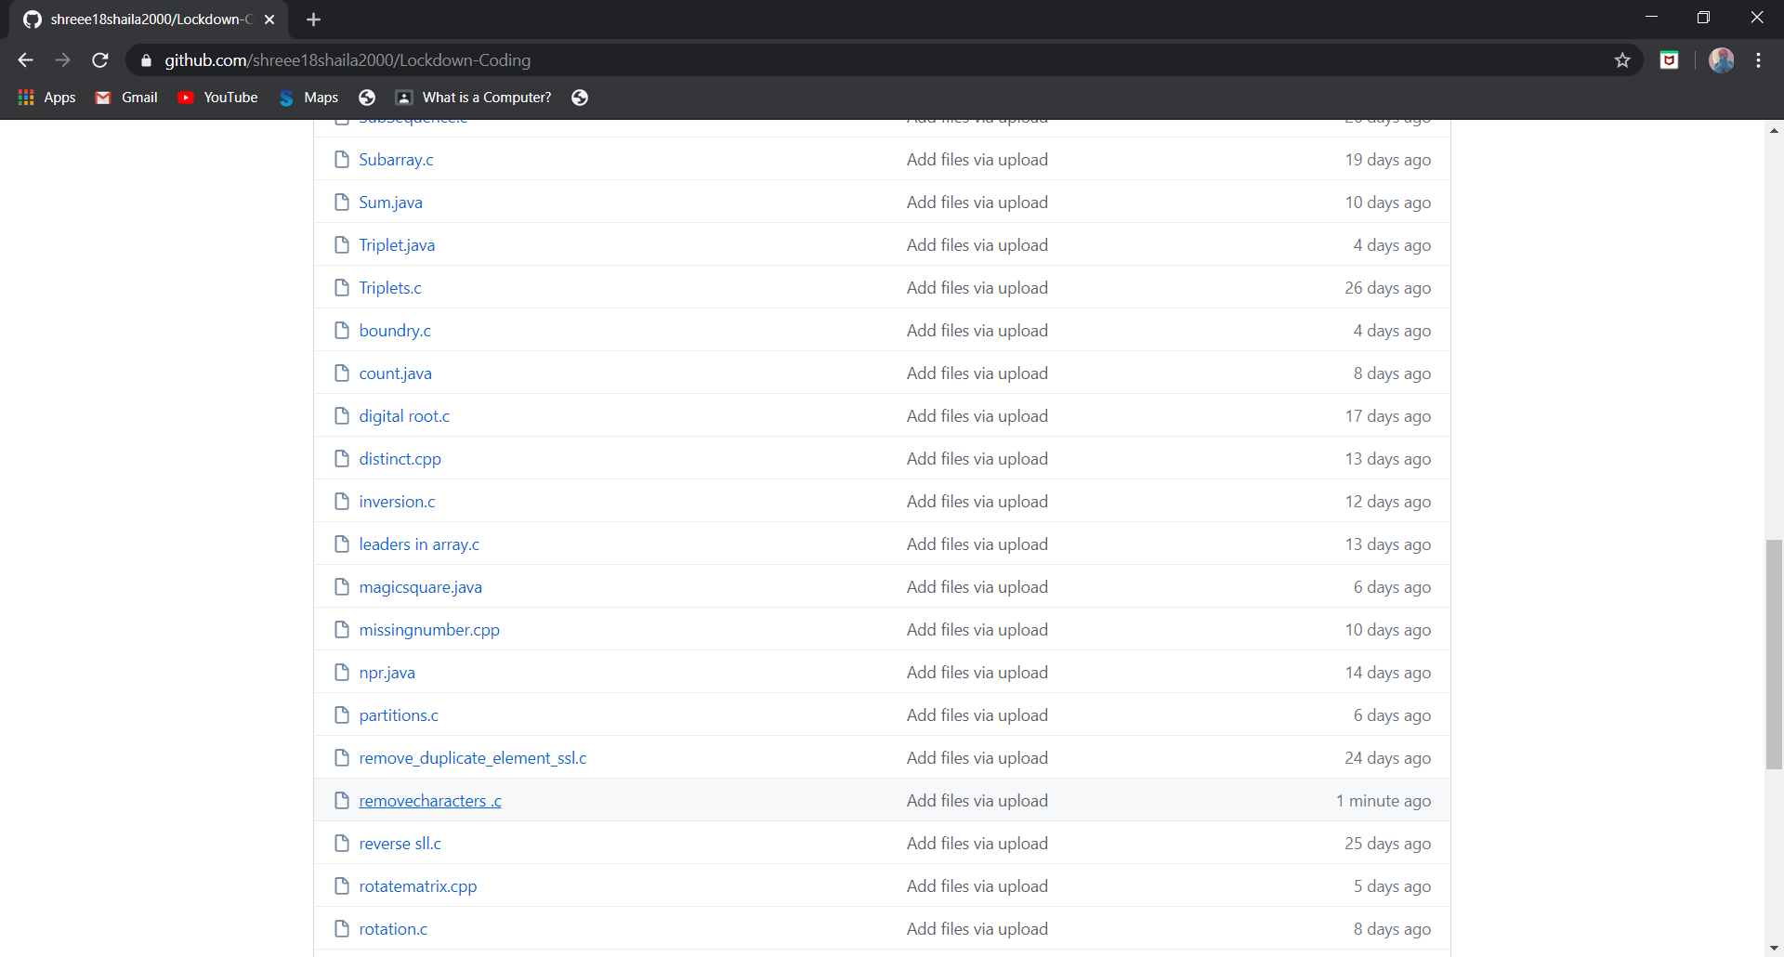

**This is the snap shot of my GitHub repository** were I have uploaded the code. File name is removecharacters.c